Segmented Bar Charts
Objective
To create a Segmented Bar Chart in R with the barplot function using categorical data, which is a collection of numbers that represent frequencies (or counts) of events or outcomes that fall into different groups or categories. You need to have your data organized in terms of TWO categorical variables for this to work.
Background
A segmented bar chart, like a plain-old-ordinary bar chart, uses rectangular segments to visualize categorical data. The lengths of the bars are proportional to the values they represent, and the bars can be oriented vertically or horizontally.
- A segmented bar chart has one bar for each level of a particular categorical variable (called a "segment" of the sample).
- The segmented bar chart is a frequency distribution. Segmented bar charts are usually scaled so all of the bars reach the 100% mark on the vertical axis.
- The information contained in one of the bars is called a conditional distribution, because it's the distribution of observed cases for which the condition of an additional categorical variable having a given value is met.

Data Format
To create a segmented bar chart, all you need is a contingency table containing counts of data organized by at least two categorical variables. The following examples are based on M&M data stored within a CSV (comma separated variable) file, where the filename is mnm-data.csv, and the first row of my data file contains variable names. The three variables are: mnm (the order I pulled the M&Ms from the bag; first M&M pulled would be "1"), color, and defect. I have six color codes (BL = blue, BR = brown, G = green, Y = yellow, O = orange, R = red) and four defect codes (N = no defects, C = cracked or chipped, L = letter is missing or improperly printed on the M&M, and M = multiple defects).
Code and Results
1) Creating the Contingency Table. Use setwd() first to point R to the directory where the CSV file containing your data is located. Once getwd() echoes the directory you are expecting, I read my data in to the M&M data frame that I call mm.df:
mm.df <- read.csv("mnm-data.csv",header=T)
The table command is used to generate a contingency table from the data frame. I'm calling my M&M contingency table mm.ct so I can distinguish it from mm.df:
mm.ct <- table(mm.df$color,mm.df$defect)
If I were to read out loud what the code on the right hand side says, I would say "I am creating a contingency table whose rows will be the color data from the data frame mm.df, and whose columns will be the defect data from the data frame mm.df." I am creating a contingency table with the (rows,columns) that I specify as an argument to table.
The dollar-sign notation means that I am accessing a variable within a data frame. For example, mm.df$count means that I want the count data from the data frame named mm.df. Whenever you see notation in R in the form data.frame$variable this means that you want to access the variable named variable which is part of the data frame called data.frame.
When you display the contingency table, it will look like this. Using my data set, you can see that I observed 3 M&Ms that were both blue and chipped, 8 orange M&Ms with no defects, and so on.
> mm.ct

C L M N
BL 3 0 1 8
BR 1 0 0 5
G 0 2 0 6
O 1 0 1 8
R 0 0 0 6
Y 2 0 0 5

2) Producing the Segmented Bar Chart. First, decide whether you want to create a segmented bar chart for the data in the COLUMNS of your contingency tables, or the data in your ROWS. In our contingency table that we called mm.ct, defects are in the columns, and colors are in the rows. So if we choose COLUMNS, we will be producing a segmented bar chart showing the distribution of colors by defects. If we choose ROWS, we will be producing a segmented bar chart showing the distribution of defects by color.
If you choose COLUMNS, you will produce the bar chart by creating a table of proportions (prop.table) from the COLUMNS (that's what the number 2 is for) of the contingency table called mm.ct, like this:
barplot(prop.table(mm.ct,2))
You can add all kinds of nice arguments to this to make the chart prettier. For example,
barplot(prop.table(mm.ct,2),main="Distribution of M&M Colors by Defect Category",xlab="defect",ylab="percent",col=mm.colors)
produces the segmented bar chart in Figure X.1.
If you choose ROWS, you will produce the bar chart by creating a table of proportions (prop.table) from the ROWS (that's what the number 1 is for) of the contingency table called mm.ct. Only in this case, we have to transpose the table of proportions using the t command to make it all work:
barplot(t(prop.table(mm.ct,1)))
You can add all kinds of nice arguments to this too. For example,
barplot(t(prop.table(mm.ct,1)),main="Distribution of M&M Defects by Color",xlab="color",ylab="percent",col=mm.colors,legend=TRUE,
names.arg=mm.colors)

produces the segmented bar chart in Figure X.2.
(Note that in example where we are displaying the segmented bar chart of M&M defects by color, we've chosen mm.colors as the color scheme for the argument to col, BUT the colors no longer align with the actual M&M colors.
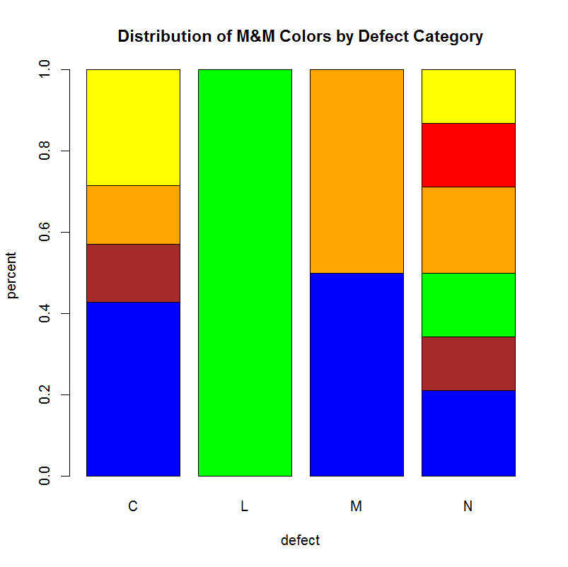
Figure X.1: Chart produced by barplot on the columns of a contingency table
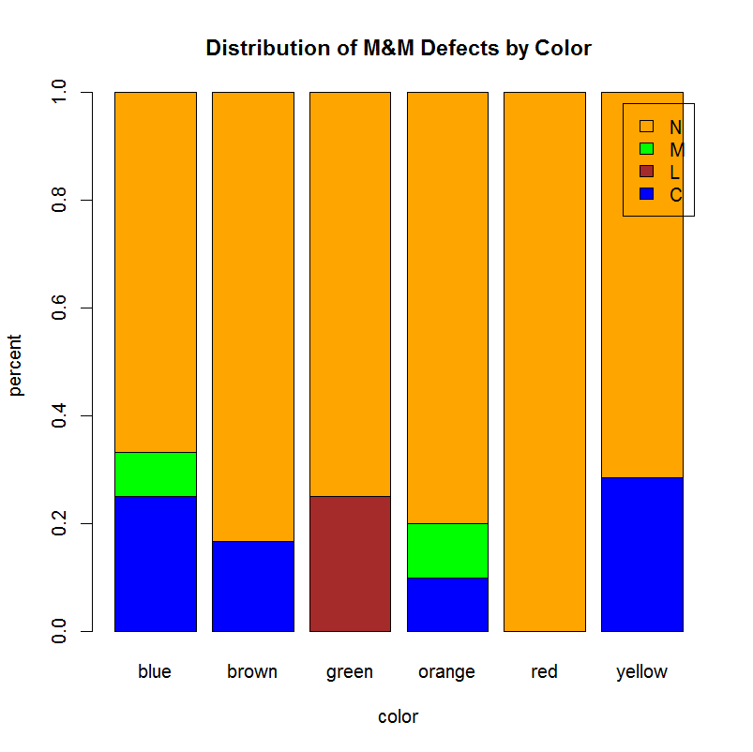
Figure X.2: Chart produced by barplot command executed on a data frame
In this case, the legend overlaps the top right corners. There are ways to more finely tune the graphics in R so that the legend appears outside the bounds of the graph, but these methods will not be covered in this chapter.

There are many optional arguments that you can add to your bar chart using barplot, some of which you've seen in the examples above. My favorites are in Table X.1 below.
Option | What it does
main | Specify a main title to be displayed above chart
xlab | Specify text to describe the x-axis
ylab | Specify text to describe the y-axis
col=mm.colors | Sets the color palette to the colors that you have designated in the vector mm.colors
names.arg=mm.colors | Instead of labeling the x-axis with the categories from the raw data, this argument enables you to set up new labels for the bars, which can be useful if you are generating a bar chart from data within a data frame
legend=TRUE | Adds a box with a legend to the plot
horiz=TRUE | Orients the display of the bars horizontally instead of vertically
density=10 | Makes shaded bars instead of solid (I like to choose values between 8 and 22 here)
Table X.1: Optional arguments that can be used with barplot to make a prettier chart

Conclusions
Segmented bar charts are used to visualize conditional distributions, which show the distribution of one variable for only the cases that match a second condition. For any contingency table that describes counts or proportions in terms of two categorical variables (that is, a two-way table), one segmented bar chart can be constructed for each of the two categorical variables.

